**Q1. Given this array: `[3,62,234,7,23,74,23,76,92]`, Using arrow function, create an array of the numbers greater than `70`.**

var arr=[3,62,234,7,23,74,23,76,92];

var arr1 =arr.filter(value=>{return value>70;});

console.log(arr1);

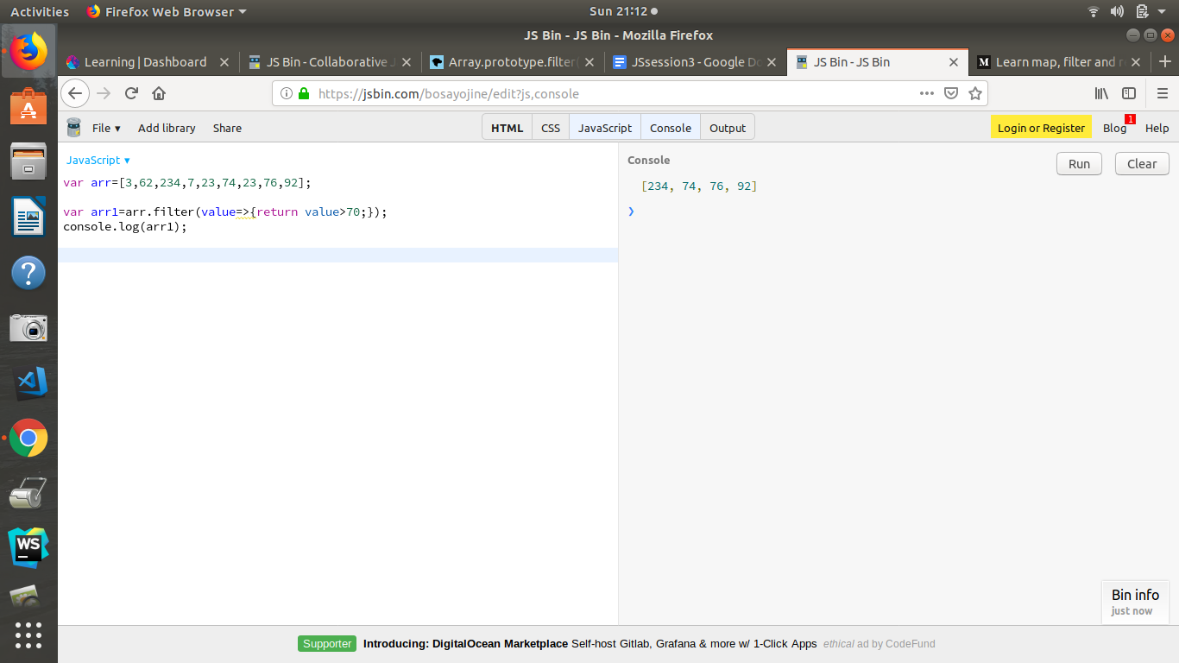

**Q2.**

**<ul>**

**<li data-time="5:17">Flexbox Video</li>**

**<li data-time="8:22">Flexbox Video</li>**

**<li data-time="3:34">Redux Video</li>**

**<li data-time="5:23">Flexbox Video</li>**

**<li data-time="7:12">Flexbox Video</li>**

**<li data-time="7:24">Redux Video</li>**

**<li data-time="6:46">Flexbox Video</li>**

**<li data-time="4:45">Flexbox Video</li>**

**<li data-time="4:40">Flexbox Video</li>**

**<li data-time="7:58">Redux Video</li>**

**<li data-time="11:51">Flexbox Video</li>**

**<li data-time="9:13">Flexbox Video</li>**

**<li data-time="5:50">Flexbox Video</li>**

**<li data-time="5:52">Redux Video</li>**

**<li data-time="5:49">Flexbox Video</li>**

**<li data-time="8:57">Flexbox Video</li>**

**<li data-time="11:29">Flexbox Video</li>**

**<li data-time="3:07">Flexbox Video</li>**

**<li data-time="5:59">Redux Video</li>**

**<li data-time="3:31">Flexbox Video</li>**

**</ul>**

**a)Select all the list items on the page and convert to array.**

var list = document.getElementsByTagName('li');

var theArray = [];

for (var i = 0; i < list.length; i++) {

var arrValue = list[i].innerHTML;

theArray.push(arrValue);

}

console.log(theArray);

**b)Filter for only the elements that contain the word 'flexbox'**

var flexbox = theArray.filter(name =>name.includes('Flexbox'));

console.log(flexbox);

**c)map down to a list of time strings.**

**d)map to an array of seconds.**

**e)reduce to get total using .filter and .map**

**<!DOCTYPE html>**

**<html>**

**<head>**

**<title>Javascript</title>**

**</head>**

**<body>**

**<ul>**

**<li data-time="5:17">Flexbox Video</li>**

**<li data-time="8:22">Flexbox Video</li>**

**<li data-time="3:34">Redux Video</li>**

**<li data-time="5:23">Flexbox Video</li>**

**<li data-time="7:12">Flexbox Video</li>**

**<li data-time="7:24">Redux Video</li>**

**<li data-time="6:46">Flexbox Video</li>**

**<li data-time="4:45">Flexbox Video</li>**

**<li data-time="4:40">Flexbox Video</li>**

**<li data-time="7:58">Redux Video</li>**

**<li data-time="11:51">Flexbox Video</li>**

**<li data-time="9:13">Flexbox Video</li>**

**<li data-time="5:50">Flexbox Video</li>**

**<li data-time="5:52">Redux Video</li>**

**<li data-time="5:49">Flexbox Video</li>**

**<li data-time="8:57">Flexbox Video</li>**

**<li data-time="11:29">Flexbox Video</li>**

**<li data-time="3:07">Flexbox Video</li>**

**<li data-time="5:59">Redux Video</li>**

**<li data-time="3:31">Flexbox Video</li>**

**</ul>**

**<p></p>**

**<script type="text/javascript">**

**// Select all the list items on the page and convert to array**

**const items = Array.from(document.querySelectorAll('[data-time]'));**

**// Filter for only the elements that contain the word 'Flexbox'**

**const filtered = items**

**.filter(item => item.textContent.includes('Flexbox'))**

**// map down to a list of time strings**

**.map(item => item.dataset.time)**

**// map to an array of seconds**

**.map(timecode => {**

**const parts = timecode.split(':').map(part => parseFloat(part));**

**return (parts[0] * 60) + parts[1];**

**})**

**// reduce to get total**

**.reduce((Total, seconds) => Total + seconds);**

**console.log(filtered);**

**document.querySelector('p').textContent = `Total time for all the Flexbox videos: ${filtered}s`;**

**</script>**

**</body>**

**</html>**

**Q3. Create a markup template using string literal**

**const song = {**

**name: 'Dying to live',**

**artist: 'Tupac',**

**featuring: 'Biggie Smalls'**

**};**

**Result:**

**"<div class="song">**

**<p>**

**Dying to live — Tupac**

**(Featuring Biggie Smalls)**

**</p>**

**</div>**

**“**

const song = {

name: 'Dying to live',

artist: 'Tupac',

featuring: 'Biggie Smalls'

};

const markup = `

<div class="song">

<p>

${song.name} - ${song.artist}

(Featuring ${song.featuring})

</p>

</div>

`;

document.body.innerHTML = markup;

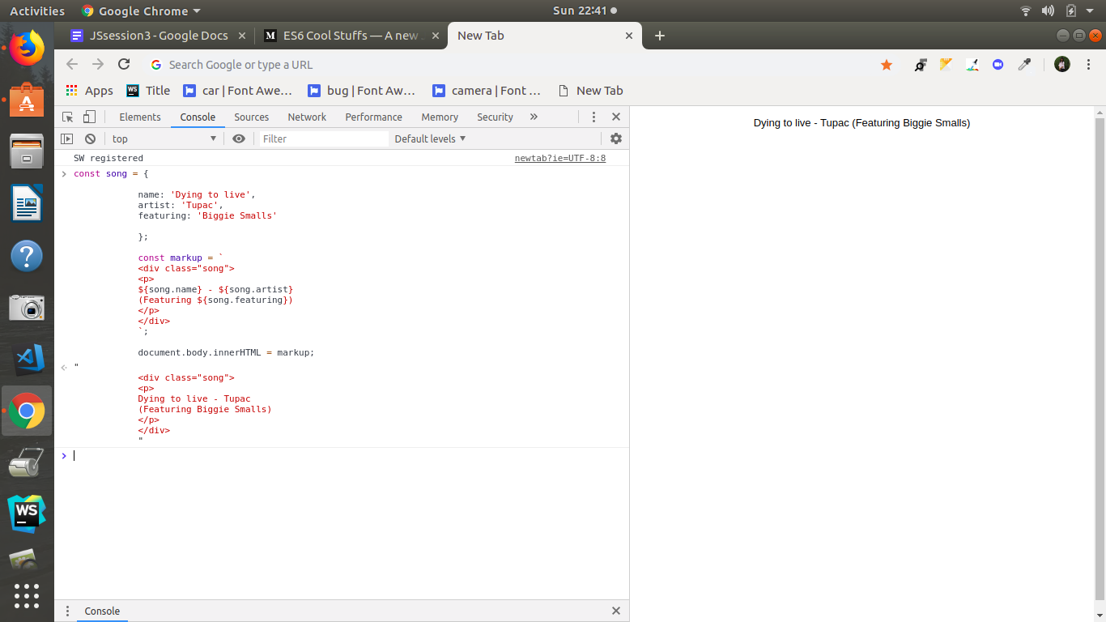

**Q4. Extract all keys inside address object from user object using destructuring ?**

**const user = {**

**firstName: ‘Sahil’,**

**lastName: ‘Dua’,**

**Address: {**

**Line1: ‘address line 1’,**

**Line2: ‘address line 2’,**

**State: ‘Delhi’,**

**Pin: 110085,**

**Country: ‘India’,**

**City: ‘New Delhi’,**

**},**

**phoneNo: 9999999999**

**}**

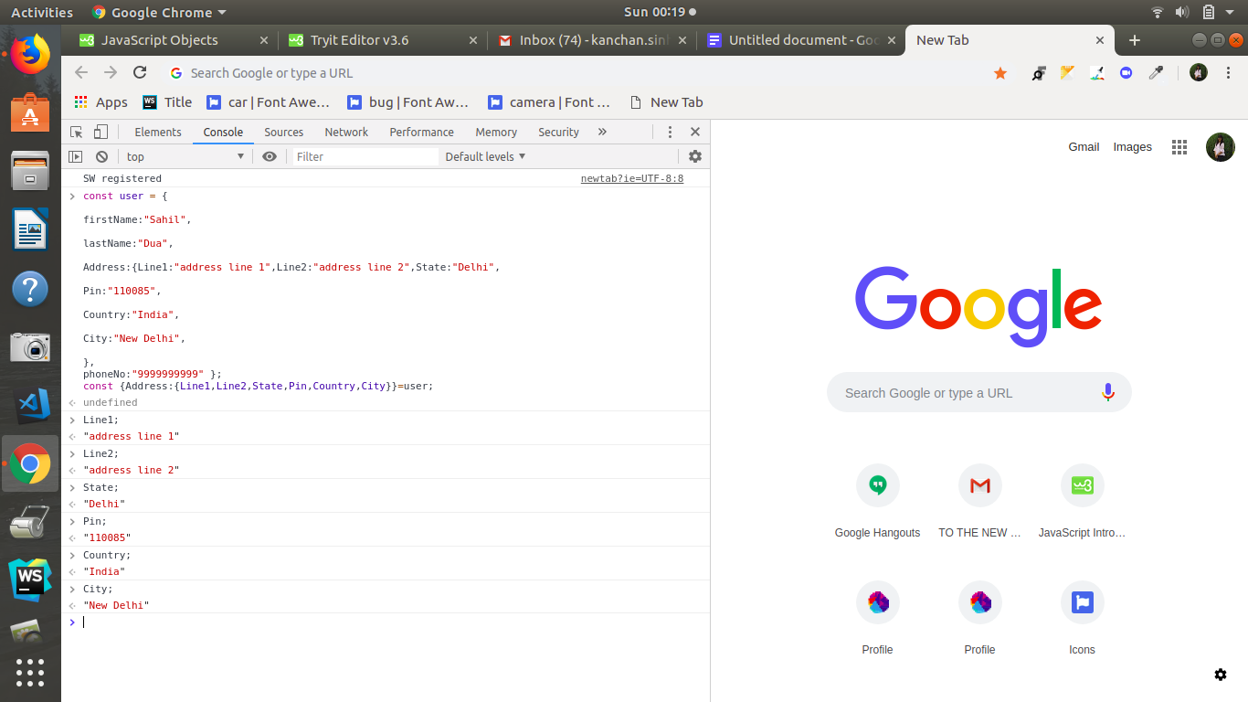

const user = {

firstName:"Sahil",

lastName:"Dua",

Address: {

Line1:"address line 1",

Line2:"address line 2",

State: "Delhi",

Pin: "110085",

Country: "India",

City: "New Delhi",

},

phoneNo: "9999999999"

};

const { Address:{Line1,Line2,State,Pin,Country,City}}=user;